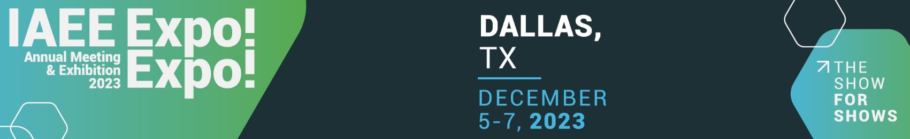

Date __________________

Dear___________________,

I would like to attend the 2023 IAEE Expo! Expo! Annual Meeting & Exhibition, 5-7 December in Dallas, TX. The conference will enable me to attend a number of education sessions that are directly applicable to my work and will allow me to network with a variety of industry experts and colleagues.

The education sessions will provide me with tools to reduce costs, increase reach, motivate attendance, etc. The areas of focus for Expo! Expo! education include Building & Retaining Talent, Exploring Event Technology, Surveying the Exhibition Landscape of Tomorrow, Innovative Sales & Sponsorship Solutions, Marketing Matters, and The Business of Legal. The presentations are facilitated by both industry experts and colleagues who have faced similar challenges. I am confident I will be able to connect with leading trade show organizers to learn more about their business recovery plans and how they are maximizing profitability.

In addition, Expo! Expo!, the exhibition, will offer in person access to over 200 suppliers serving the industry. This will be a great opportunity to develop new relationships for supplier partnerships and to identify new solutions for our trade show business.

I am seeking approval for registration fees, travel expenses to the conference and hotel accommodations during the event. A detailed cost breakdown is included below. The full price conference fee for an organizer is $969, but can be reduced to $769 by registering before 20 October 2023.

Here is the breakdown of event costs:
Registration Fee: $
Hotel: $
Airfare: $
Transportation: $
Other (Meals, Per Diem, Etc.): $
The total costs associated with attending Expo! Expo!: $

I will bring back my key takeaways to implement and share with our organization to strengthen our engagement, enhance efficiency and productivity and impact our bottom line. Upon my return from IAEE’s Expo! Expo! Annual Meeting & Exhibition, I will provide you with a report on how I will be able to apply what I learned. I will tie these learnings to our organizations short-term and long-term goals, marketing plan, budget and strategic plan. I assure you that by attending this event, I will provide added value to our company.

Sincerely,

____________________________

